Anahise Garcia
Introduction to Computer Science – CS1101
December 5th, 2025
Comprehensive Lab Report (CL3)

A nostalgic classic game with an old-school feel, this newly expanded battle simulator brings your favorite heroes and villains to life across four universes—Pokémon, Star Wars, Marvel, and DC. Whether you want to play solo, battle a friend, or sit back and watch two computer-controlled fighters go head-to-head, this upgraded version has something for every strategist. With smart medium-level AI opponents, fully simulated recursive battles, and an all-new tournament mode, every match feels dynamic and unpredictable. The shift to an object-oriented design provides cleaner gameplay, smoother turns, and richer character interactions. Choose your champion, perfect your strategy, and dive into this more powerful, more polished battle simulator experience.
This lab deepened my understanding of object-oriented programming and how large programs become easier to manage once responsibilities are divided across classes. Moving character stats and behaviors into a dedicated Character class made the game logic far more structured, and having a Game class to control the flow of gameplay helped me understand how objects can interact in a code. I also learned how important proper attribute management is with making sure of HP resets, attacks update the correct object, and that file loaded characters are stored correctly.
Another major learning moment was recursion. Comprehensive Lab 2 introduced recursive battles, but Comprehensive Lab 3 required me feel more confident in creating a recursive method. At first, recursion still felt unintuitive but rebuilding it inside the new class framework helped me understand how base cases, parameters, and flow control work together. I also gained more confidence in input validation and creating reusable helper methods to keep the game stable no matter what the user enters.
The biggest challenge in this lab was transitioning from array based code to full class based design. It required rewriting nearly every action, attack, heal, turn taking logic, and ensuring each method updated the correct object's attributes. Debugging became more involved because mistakes didn't always crash the program. However, I did find myself not losing myself in my code quite as much as I did with the other two comprehensive labs, give the multiple classes.
Another challenge was implementing recursion again and to support multiple modes, including the tournament system. Making sure recursion ended correctly, avoided infinite loops, and returned the correct winner took several adjustments. Finally, adding a brand new game mode forced me to think creatively about how to reuse existing methods while still providing a unique experience for the player. I also had difficulty thinking of a new game mode to implement, given that I do not play games very often. I thought about recruiting a classmate or a friend who could possibly give me a really creative idea, but I thought it was best to try to find a way to go over some of the codes I had issues with prior.
Below are test cases, each demonstrating program correctness and how invalid input is handled.
Universe Selection + Invalid Input Handling to confirm that the game refuses invalid input and requires a valid universe choice.
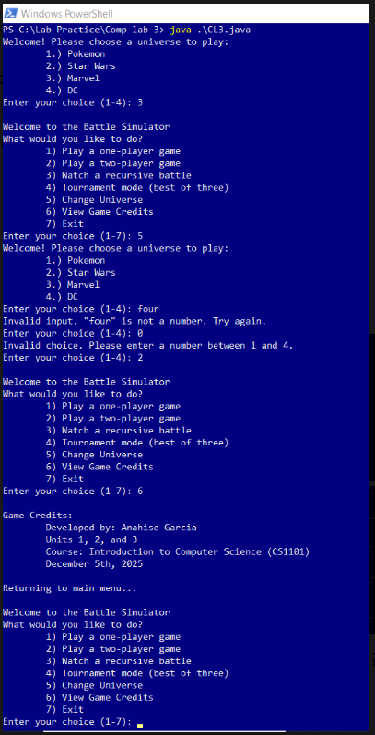
Test Case 2 – One-Player Game: Attack, Heal, Forfeit, and CPU Behavior. Verifies that all player options work and that CPU makes decisions based on difficulty.
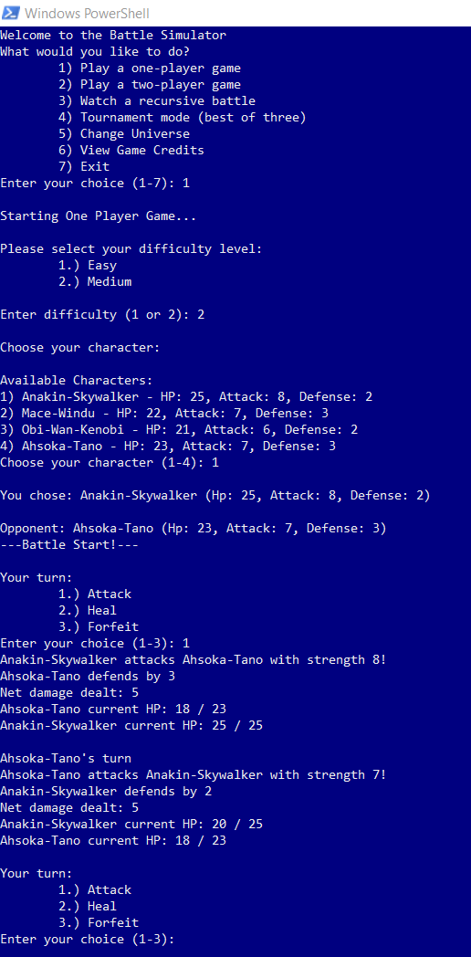

Test Case 3 – Recursive Battle + Tournament Mode. Ensures recursive battles print round-by-round progress and correctly determine winners.
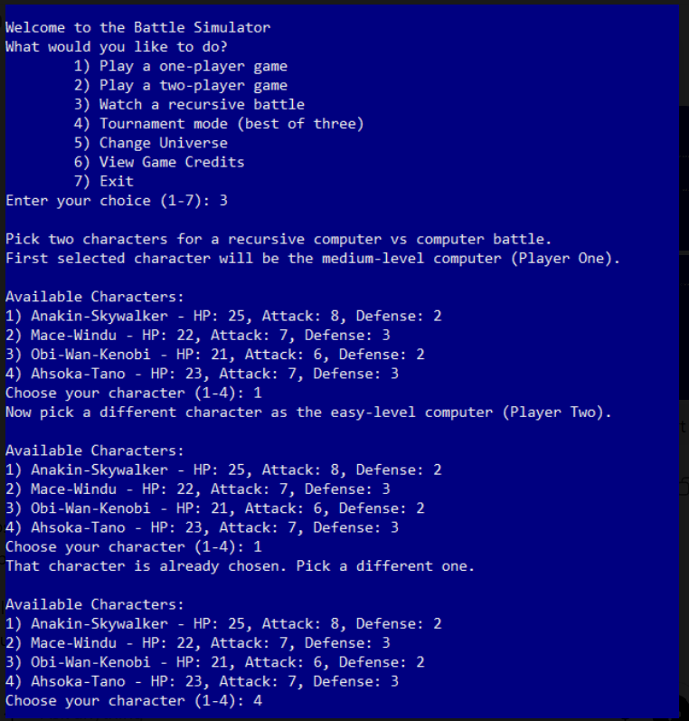
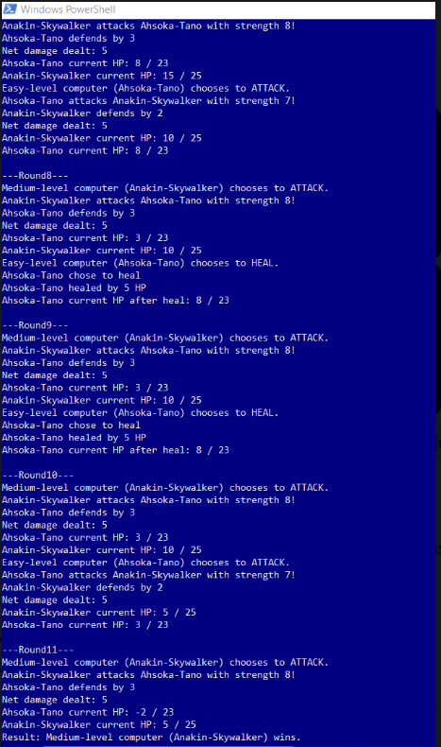
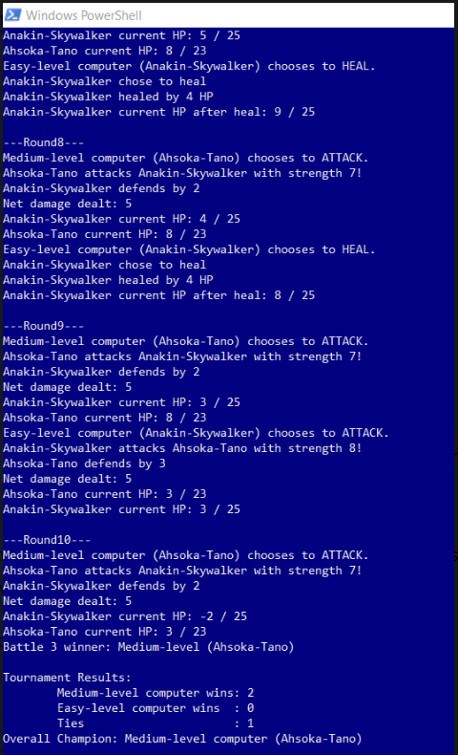

Test Case 4 – Two-Player Game. Confirm that two human players can take turns and invalid input is handled.
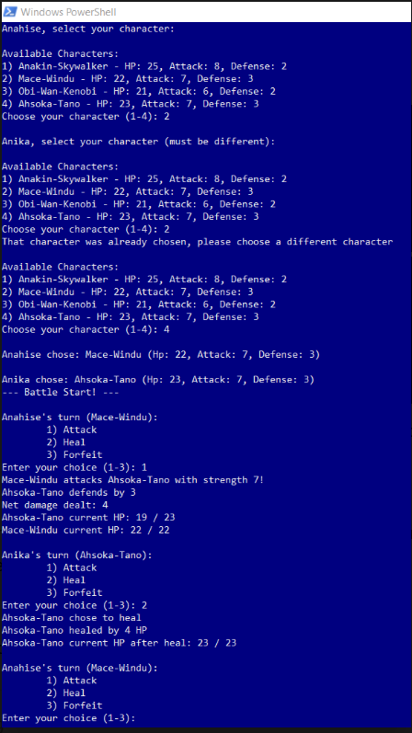

Overall, this lab significantly improved my understanding of object-oriented programming and how to structure larger projects. By integrating classes, recursion, method reuse, and full input validation, I created a more robust and user-friendly simulator than in previous labs. Although challenging, this project helped me gain confidence with recursion, method design, and class based logic. I feel proud and I am excited not only to offer this to my friends to use, but to see if I can continue to work on this to create a really fun game, even after this class.

